**Lab Practical #11:**

Visit your Institute server room and various places where racks and servers installed, identify various network components, collect information about installation of necessary hardware and software.

**Practical Assignment #11:**

1. **To identify various network components, collect information about installation of necessary hardware and software like firewall, routers, switches, etc.**
   * **Server room:**
     + The structure of server room is low-cost and unstructured.
     + All the design and implementation are done by the network administrator.
     + In this network there are two topologies are use I. Star Topology, II. Ring Topology.
     + There are some components are use in this internet connection network Like Switch, router, ethernet cable, media convertor, fiber-optic cable, Fire Wall, etc.
     + One individual ethernet cable comes from all labs of 1st, 2nd, 3rd floor.
     + All the ethernet cable is connected to the switches in the server room.
     + the “**cisco**” switches (**24 ports**) are use in the network connection.
     + For provide connection to all buildings of campus through fiber-optic.
     + In server room, we use media convertor for connect ethernet cable to fiber-optic cable.
     + This ethernet cable is connected to switch.
     + All the switches and firewall are interconnected in ring topology structure.
     + In the server room we use **SOPHOS XGS 2100** Firewall.
     + 2 uplink port are use in firewall for network antenna to get wireless internet connection through internet service provider.
   * **Building(a) – switching room:** 
     + The switching room is placed in building – A (Other buildings).
     + In the switching room some components are use like switch (24-port), media convertor, fiber-optics, ethernet cable.
     + All the lab’s computers connected to the switch and one common wire connected to fiber-optic through media converter.
     + Fiber-optic provide connection between two buildings.
     + Here one more fiber-optic is used because one internet service provider’s wireless antenna is located on terrace of building - A.
     + At this time media convertor is again in picture because it is used to convert from ethernet cable to fiber-optic cable which is pass through underground cabling pattern to the building C.
     + Also use wired connection on the terrace between two building.
   * **Terrace – Antenna:**
     + There are 3 wireless antenna are used
     + 2 are of same company.
     + 1 is of another company.
     + 2 antenna are use for regular usage.
     + And other one use as a backup of internet.
     + If in any situation, some problem faced in antenna of one company then other company’s internet service will be used.

* **Components**
  + **Firewall**

A firewall can be defined as a special type of network security device or a software program that monitors and filters incoming and outgoing network traffic based on a defined set of security rules. It acts as a barrier between internal private networks and external sources (such as the public Internet).

The primary purpose of a firewall is to allow non-threatening traffic and prevent malicious or unwanted data traffic for protecting the computer from viruses and attacks. A firewall is a cybersecurity tool that filters network traffic and helps users block malicious software from accessing the Internet in infected computers

A firewall can be a network security device or a software program on a computer. This means that the firewall comes at both levels, i.e., hardware and software, though it's best to have both.

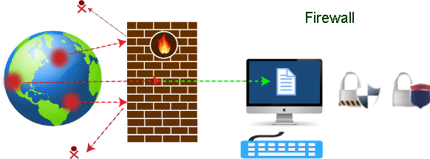

* + **Routers**

The router is a physical or virtual internetworking device that is designed to receive, analyze, and forward data packets between computer networks. A router examines a destination IP address of a given data packet, and it uses the headers and forwarding tables to decide the best way to transfer the packets. There are some popular companies that develop routers; such are Cisco, 3Com, HP, Juniper, D-Link, Nortel, etc. Some important points of routers are given below.

* + - A router is used in LAN (Local Area Network) and WAN (Wide Area Network) environments. For example, it is used in offices for connectivity, and you can also establish the connection between distant networks such as from Bhopal to.
    - It shares information with other routers in networking.
    - It uses the routing protocol to transfer the data across a network.
    - Furthermore, it is more expensive than other networking devices like switches and hubs.
  + 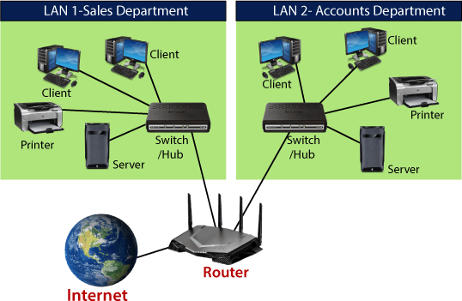**Switches**

Switches are networking devices operating at layer 2 or a data link layer of the OSI model. They connect devices in a network and use packet switching to send, receive or forward data packets or data frames over the network.

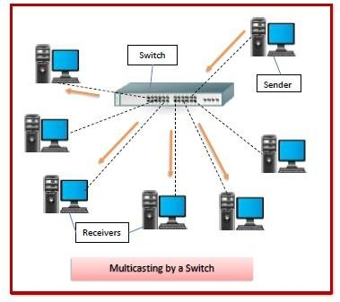A switch has many ports, to which computers are plugged in. When a data frame arrives at any port of a network switch, it examines the destination address, performs necessary checks and sends the frame to the corresponding device(s).It supports unicast, multicast as well as broadcast communications.

* + **Fiber Media Convertor**

A fiber media converter is a simple networking device that connects and translates signals between fiber optic cabling and another type of cabling media such as UTP (unshielded twisted pair) copper Ethernet cables as shown below.

It translates electronic signals to light signals and vice versa.

Media converters work on the physical layer of the network. They receive data signals from one media (such as electronic signal on a twisted pair copper cable) and convert them to another (such as light pulses on a fiber optic cable) while remaining invisible to other networking devices.

Media converters are as simple to install as patch cables and connectors. They do not interfere with upper-level protocol information. This makes them support Quality of Service (QoS) and Layer 3 switching.

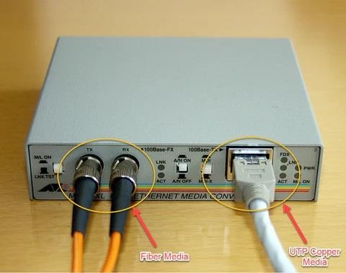

# Gateway

Gateway is a network device used to connect two or more dissimilar networks. In networking parlance, networks that use different protocols are dissimilar networks. A gateway usually is a computer with multiple NICs connected to different networks. A gateway can also be configured completely using software. As networks connect to a different network through gateways, these gateways are usually hosts or end points of the network.

Gateway uses packet switching technique to transmit data from one network to another. In this way it is similar to a router, the only difference being router can transmit data only over networks that use same protocols.

